Case Study Workshop

Drivers

Learning Objective: Drivers
To identify the major drivers of an enterprise and to link them to strategies
Suggested time-table
Case Study | Briefing | Study | Work in teams | Present | Sample  Answer Review | Total
Driver | 10 | 15 | 20 | 15 | 5 | 65

Exercises:

- Assume you are appointed as the CEO of the new integrated business unit. What are the business drivers / strategies that you can identify?
- Assume you are appointed as the CIO of the new integrated business unit. What are the Internal (within the enterprise) and External (not present at this time in the AS IS architecture landscape, but would provide a competitive advantage) drivers / strategies that you can identify?
- Assume you are appointed as the CFO of the new integrated business unit. What are the external legislative and other non technology/business drivers that you can identify?
- Assume you are appointed as the Chief EA of the new integrated business unit. How would you document the above in the template provided and link all of them. Every technology / legislative driver /strategy should be linked to one or more business driver(s). Otherwise they are not valid.
Key Drivers:
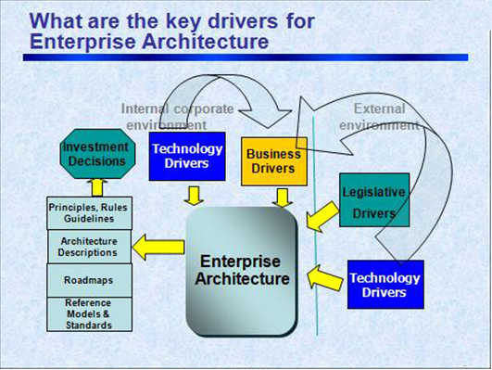

The reason for providing the template is to seek some level of consistency in the presentation of material from each team.
The template suggests a format for identifying and linking the drivers.
Q1:
Business drivers/strategies:
1.

2.

Internal Technology Drivers/strategies:
1. …

External Technology drivers
- …
- ……
- …
- …
- …

External (Non technology) drivers
- …
- …
- …
- …
- …
- …

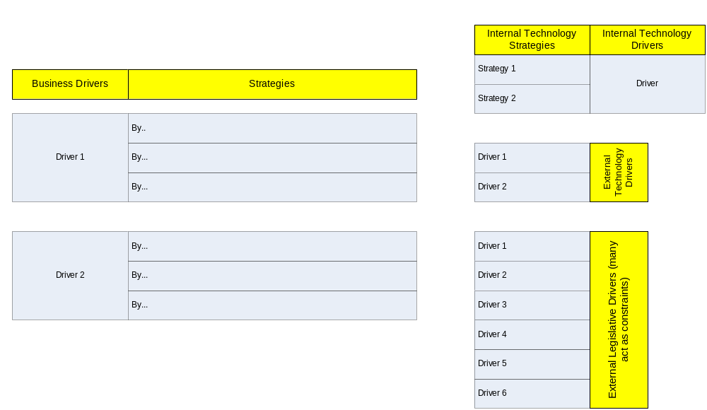 TEMPLATE

